

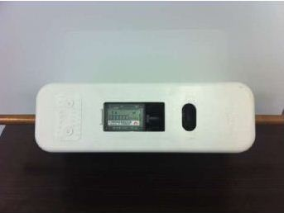

Using your keypad

Your keypad or UIU (user interface unit) can be used in one of 3 modes at any time;

1 – Standby – default, power saving mode.
The unit will always revert to standby mode after 60 seconds of in-activity, the default display is a clock in 24 hr format. The battery level display will also be present.

2 – Menu – initiated by holding down the # key, this mode allows the user to interrogate or set parameters. The UIU will indicate the status and alarms, the water droplet permanently means the valve is open, if the droplet is not displayed, then the valve is closed. A flashing droplet indicates a leak and the entire display flashing indicated that the remaining allocation is below the threshold set.
3 – Interrogate – initiated by pressing thee # key twice, this will display the remaining credit, total usage and time. Holding the # key down will result in the cursor flashing at the 1st digit position. Enter a second # and the UIU will display the 8 digit meter number.
Next the UIU will display the radio/antenna symbol as it attempts to synchronise, this can take up to 60 seconds at which point it will reset and you will need to try again.
Once the meter is synchronised it will show the remaining allocation, the meter reading, total count from start and the next time the free water allocation will be allocated. This will rotate in 5 second intervals.
You can initiate the menu options by holding the # key for a few seconds, the cursor will flash in the 1st digit position. Enter the relevant digits of the code of the desired menu item, action the selection with the # key.

Menu code :991 – Display End of Month
Menu code :993 – Set date and Time I.E(#993#HHmm#DDMMYYYY#)
Menu code :992 – Set Allocation trigger, sets off an alarm when the remaining daily allocation is below the trigger level and about to go onto pre-paid.
Menu code :998 – Display Control – the code allows the various display options to be enabled or disabled, entering the value of 1 enables and the value 0 disables .I.E #998#xxxx1#

Digit 1 – Time Display
Digit 2 – Meter Reading/Total
Digit 3 - Credit token entry enabled
Digit 4 – Not used
Digit 5 -Next allocation time.

4 – Token – pressing any numerical key first will initiate tokens mode where the meter can be topped up. 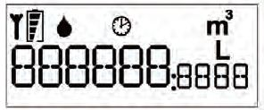
Battery level
Signal /Comms
Total Monthly Usage
Current Credit in Litres
Your display

Valve Status
Clock

